Introduction to Blockchain – Lab 1

Arda Harman – Group 22

Bitcoin

1.1 - Blocks

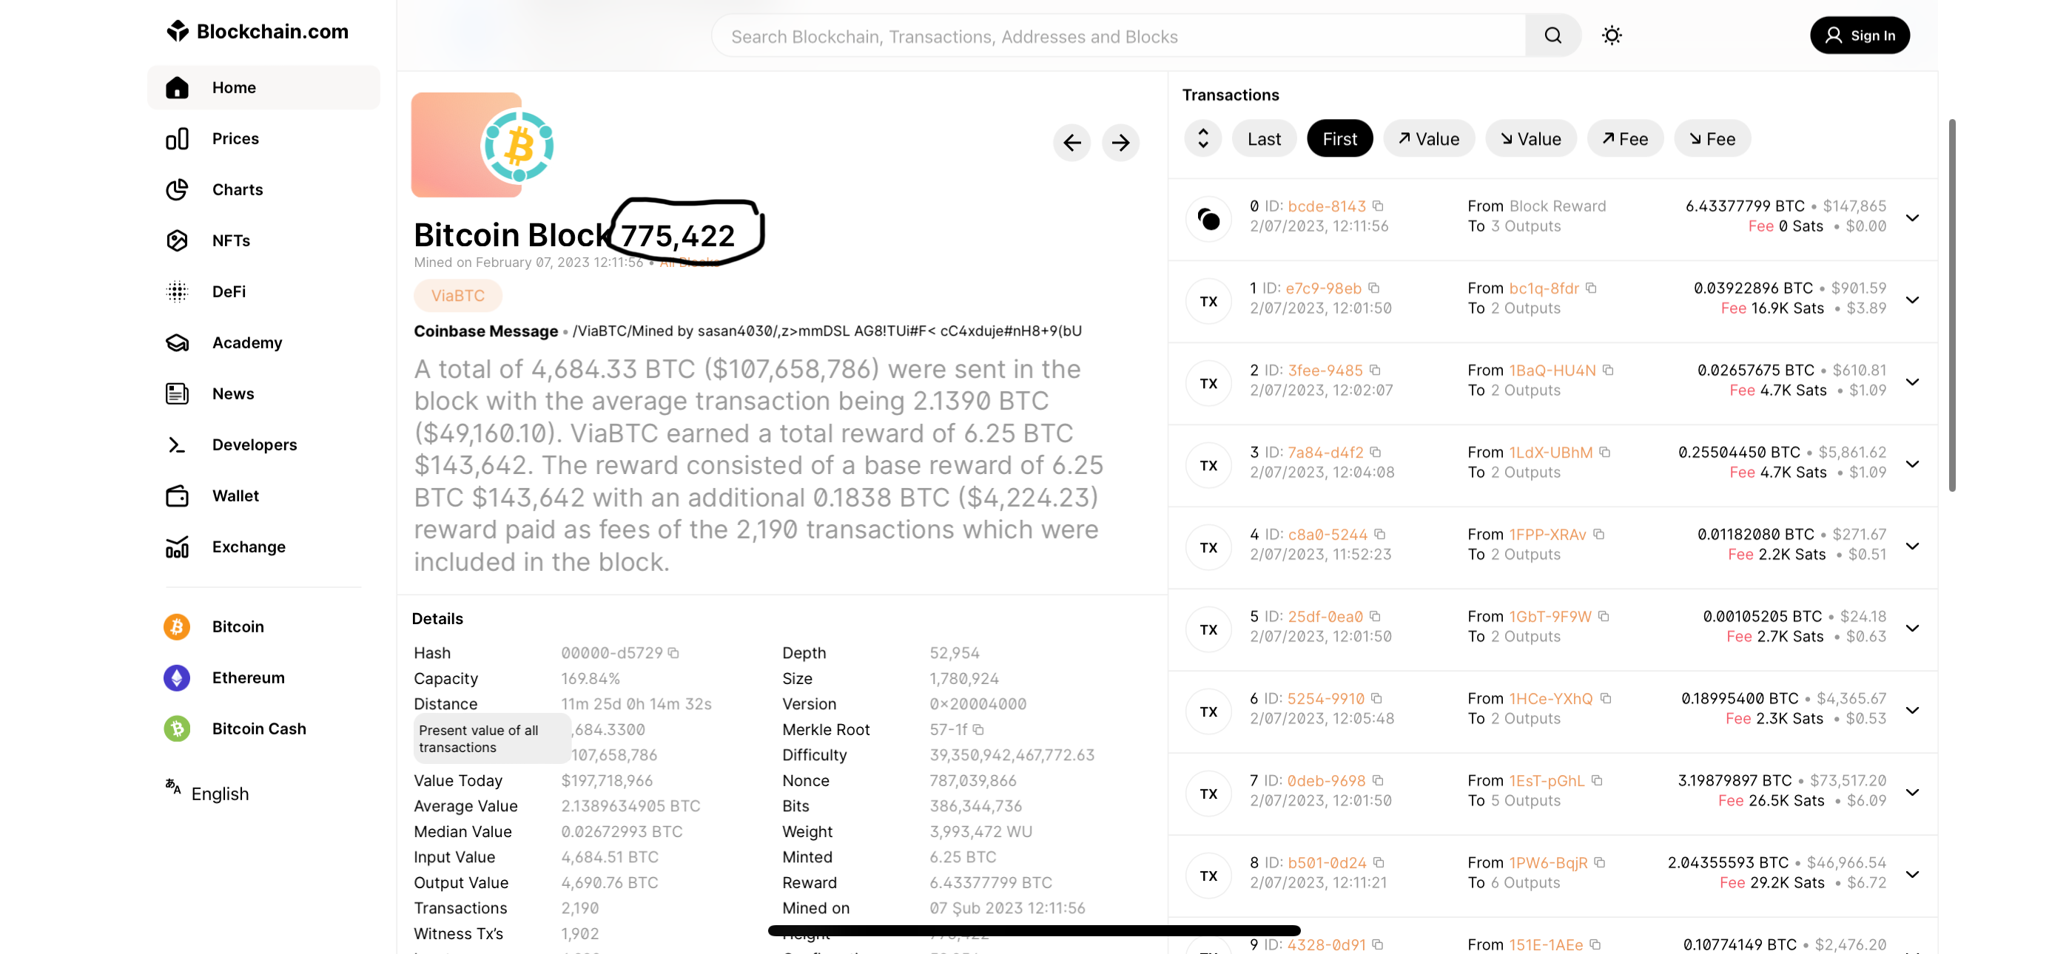Exercise 1

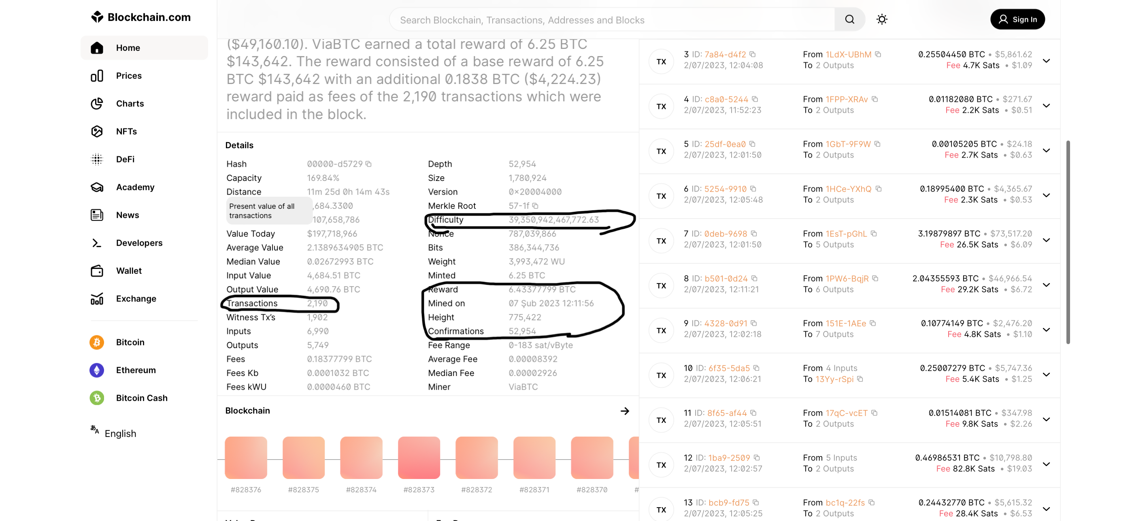Block Height: 775,422

Timestamp: 07 febrero 2023 12:11:56

Difficulty: 39,350,942,467,772.63

Number of confirmations: 52,954

Number of transactions: 2,190

Reward: 6.43377799 BTC

This reward is because “base reward + fee = reward”

6.25 + 0.1838 = 6.4338

1.2 - Difficulty

Exercise 2

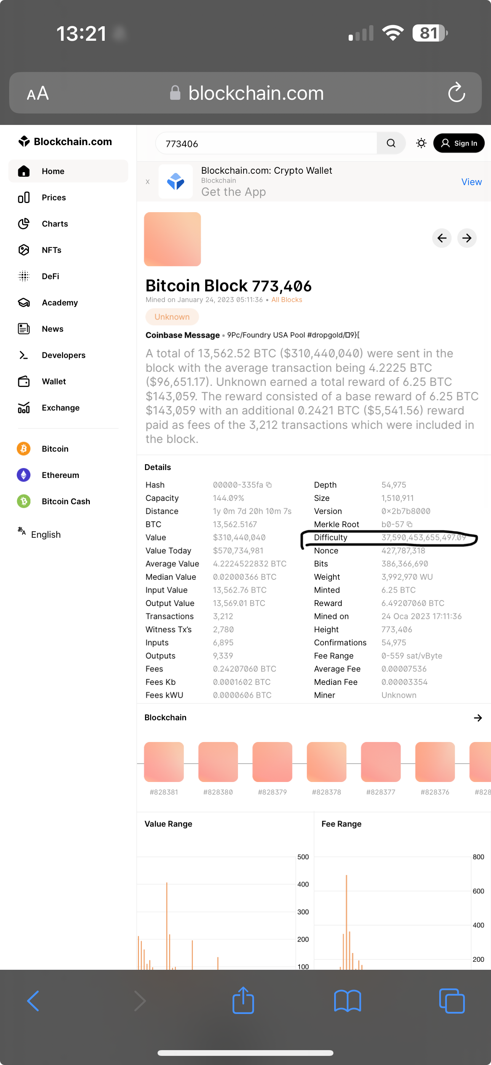

Difficulty: 37,590,453,655,497.09

In Bitcoin, it is automatically adjusted every 2016 blocks to ensure that the blocks are always mined every 10 minutes on average with the current processor technology

775,422 - 2016 = 773,406

1.3 - Miner Rewards

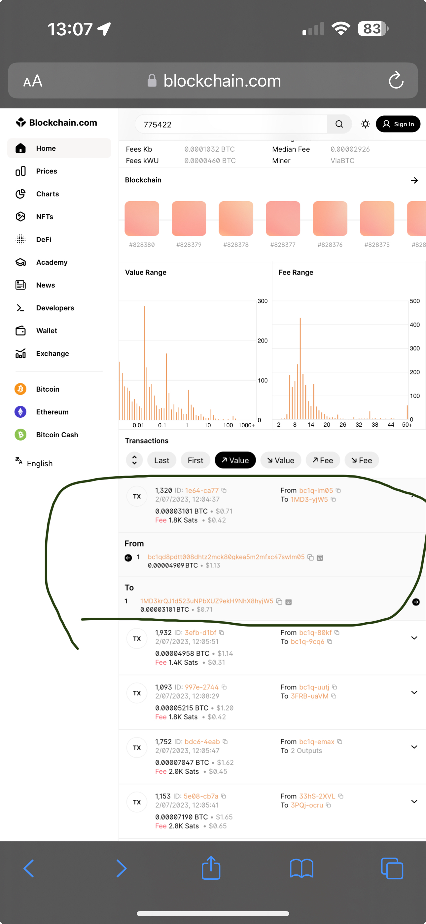Exercise 3

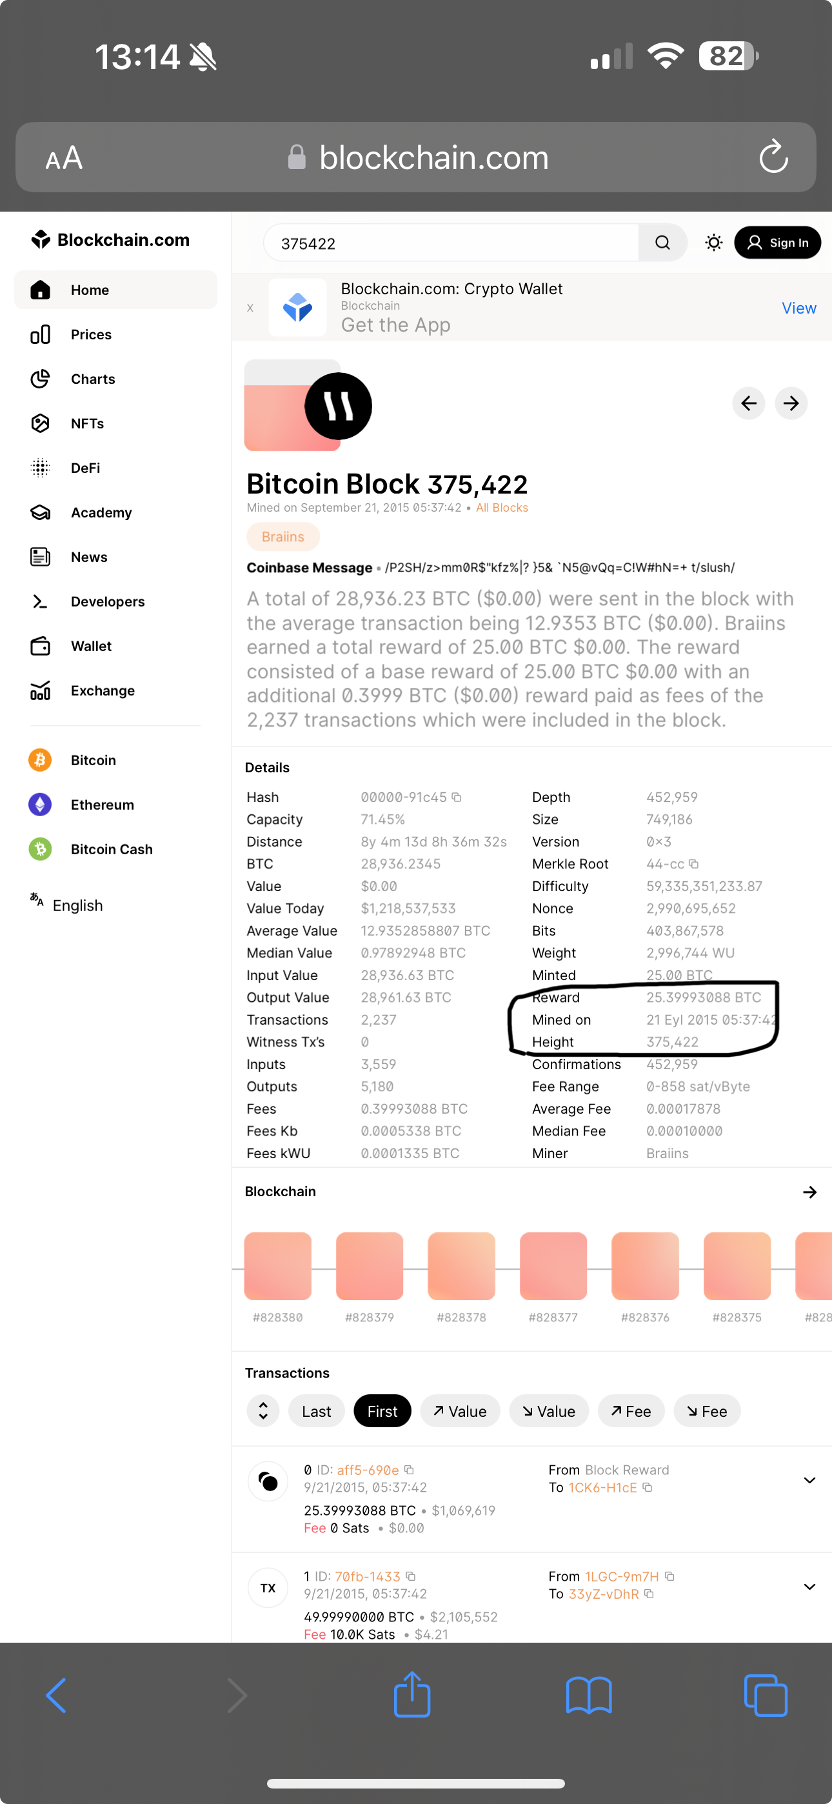

Block height: 375,422

Timestamp: 21 septiembre 2015 05:37:42

Block reward: 25.39993088 BTC

My previous block’s reward was 6.43377799BTC

and this block’s reward is 25.39993088 BTC

When we divide, we get really a close number (almost Same as 4) 3,94

(Which will be found when 25.39993088 / 6.43377799)

1.4 - Confirmations

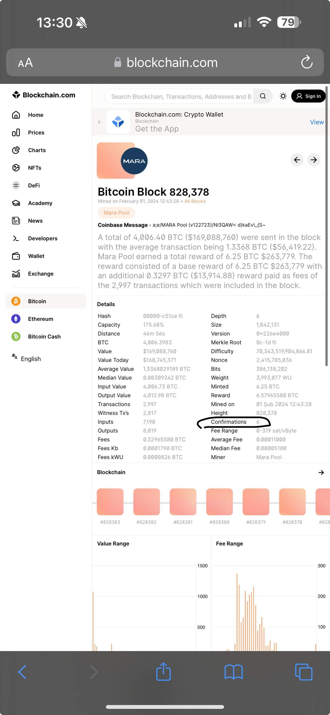Exercise 5

The usual rule in Bitcoin is to consider a transaction as valid after 6 confirmations

2. Etherium

2.1 - Transactions per Second

Exercise 6

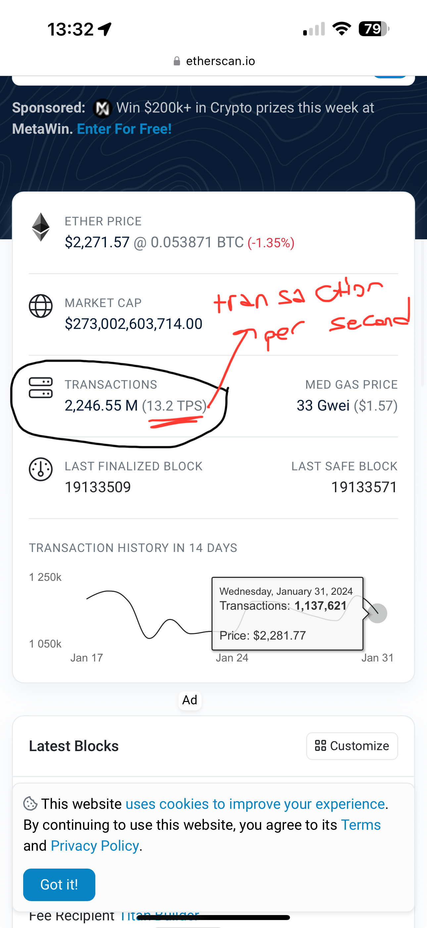

2.2 - Contract Accounts

Exercise 7

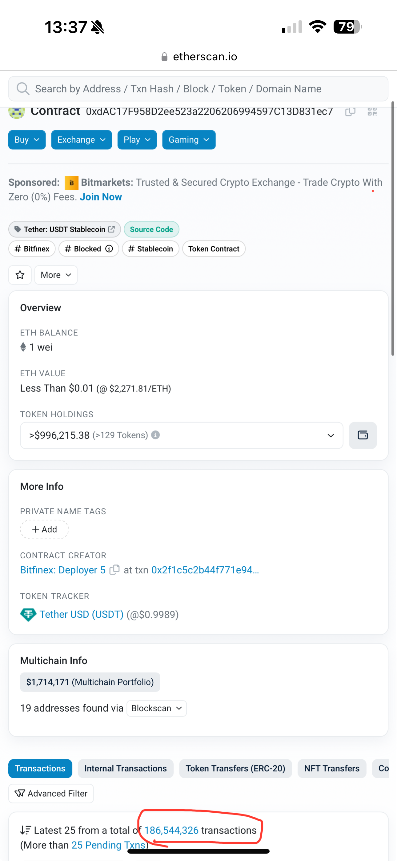

Exercise 2.3

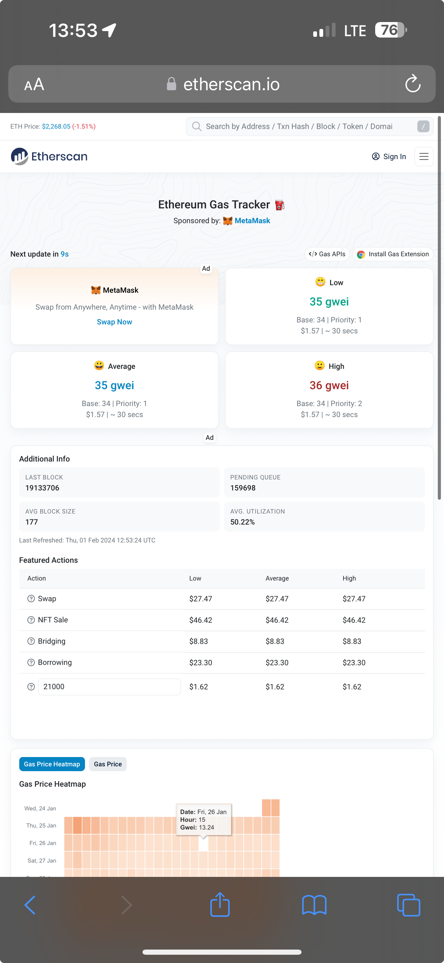

Gas cost = Average Gas Price \* Gas Consumed

= 35 gwei \* 21,000 = 735,000

- In terms of ether -

Gas Cost in Ether = Gas Cost / 1,000,000

= 735,000 / 1,000,000

= 0,735

- In terms of US dollar -

1688,45 US dollars = 0,735 Etherium